S.T.A.R. is a positive alternative where students work on personal issues, continue their education, and have access to professional services in the community. |  |  | Program Staff  Steve Stryker, Coordinator  ststryker@ccsd.k12.wy.us  307-257-0575  Certified Teacher  Major, USARNG (retired)  Betty Hansen, Program Instructor  bhansen@ccsd.k12.wy.us  307-622-7433  AAS – Police Science  Group Fitness Instructor  Teaching Effectively, Learning Successfully  1000 W. 8th Street, Gillette, WY 82716 |  |  | Philosophy  S.T.A.R. Program  Your text here  Empowerment  Education  Leadership  Life choices  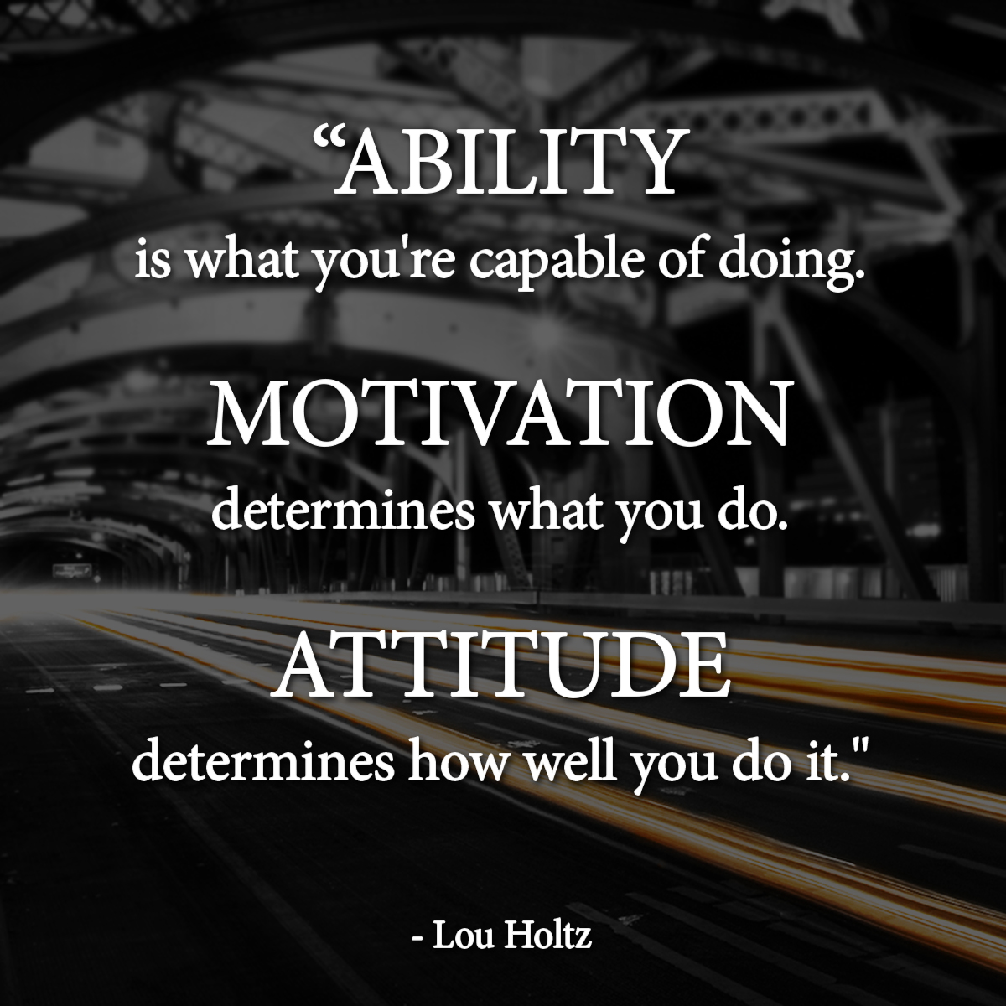
S.T.A.R. Program High School Graduates  274  You can expect…  Non-confrontational  Positive Discipline  Role Modeling  Individual Fitness  Personal Growth |  |  | District Program, free to families  Parent referral  5 school days  School Referral  15 school days  District Referral  30 School days |  |  | Star-isms…..  “Attitude and effort are the key…”  “I can do it……you can too…”  “Little things bite…”  “I can try and I will try…”  “Attention to detail…”  “Don’t cheat yourself…”  “Stand tall and be proud of who you are…”  “Today is a new day…yesterday is over…”

